MATHEMATICS PAPER I PROVISIONAL MARKING KEY

- ${2p}^{2}-2pq-12q^{2}$
$2\left[p^{2}-pq-6q^{2}\right]$ M1
$2\left[p^{2}-3pq+2pq-6q^{2}\right]$ M1
2$\left[p\left(p-3q\right)+2q(p-3q\right]$
2$\left(p+2q\right)\left(p-3q\right)$ M1 A1

2 ${2x}^{2}=12-2x$ M1
$2x^{2}+2x-12=0$ M1
$(x+3) \left(x-2\right)=0$ M1
$x=-3 or 2$ A1A1

3. $\frac{\sqrt{8t^{3}}}{\sqrt{125}}$
$\frac{\sqrt{4t^{2}×2t}}{\sqrt{25×5}}$ M1
$\frac{2t\sqrt{2t}}{5\sqrt{5}}$ M1
$\frac{2t\sqrt{2t}}{5\sqrt{5}} ×\frac{\sqrt{5}}{\sqrt{5}}$ M1
$\frac{2t\sqrt{10t}}{25}$ M1 A1
- LHS = RHS
$Q^{2}x^{2}+QNx+QNx+N^{2}≡$ ${9x}^{2}+12x+4$ M1
$Q^{2}x^{2}+2QNx+N^{2}≡{9x}^{2}+12x+4$
$Q^{2}x^{2}$=${9x}^{2}$ and $N^{2}=4$ M1
$Q^{2}=9$ M1
$Q=±3$ $N=±2$ A1 A1

- $p^{3}=$ $y^{3}\left(\frac{a}{y^{3}-a}\right)$
$p^{3}y^{3}-ap^{3}=ay^{3}$ M1
$p^{3}y^{3}-ay^{3}=ap^{3}$ M1
$y^{3}\left(p^{3}-a\right)=ap^{3}$ M1
$y^{3}=$ $\frac{ap^{3}}{p^{3}-a}$
$y=$ $\sqrt[3]{\frac{ap^{3}}{p^{3}-a}}$ M1 A1
- $C^{2}=$ $\left(\begin{matrix}0 & 1 \\ -2 & 4\end{matrix}\right)\left(\begin{matrix}0 & 1 \\ -2 & 4\end{matrix}\right)$
= $\left(\begin{matrix}0×0+1×-2 & 0×1+1×4 \\ -2×0+4×-2 & -2×1+4×4\end{matrix}\right)$ M1
$=\left(\begin{matrix}-2 & 4 \\ -8 & 14\end{matrix}\right)$ M1
$\frac{1}{2}\left(A-B+C^{2}\right)=\frac{1}{2}$ $\left[\left(\begin{matrix}1 & -3 \\ 2 & -1\end{matrix}\right)-\left(\begin{matrix}2 & -1 \\ 0 & 1\end{matrix}\right)+\left(\begin{matrix}-2 & 4 \\ -8 & 14\end{matrix}\right)\right]$ M1
=$\frac{1}{2}\left(\begin{matrix}-3 & 2 \\ 6 & 12\end{matrix}\right)$ M1
= $\left(\begin{matrix}-1.5 & 1 \\ 3 & 6\end{matrix}\right)$ A1
- ${\left(\frac{2}{8}\right)}^{3}=\frac{A}{5632}$ M1
${\left(\frac{1}{4}\right)}^{3}=\frac{A}{5632}$
$\frac{1}{64}=\frac{A}{5632}$ M1
$64A=5632$
$A=88$ cm³ ^{M1}
But $V=πr^{2}h$
88= $\frac{22}{7}×4×h$ M1
$h=7$ cm. A1

- ${2x}^{2}-x-7=0$
a = 2, $b=-1$ and c = $-7$
$x=\frac{-(-1)±\sqrt{{\left(-1\right)}^{2}-4\left(2\right)\left(-7\right)}}{2\left(2\right)}$ M1
$x=\frac{1±\sqrt{1+56}}{4}$
$x=\frac{1±\sqrt{57}}{4}$ M1
$x=\frac{1+7.549}{4}$ or $x=\frac{1-7.549}{4}$ M1
$x=2.137$ or $x=-1.637$
= 2.14 = -1.64 M1 A1

- $a+3d=\frac{1}{3}\left(a+12d\right)$ M1
$3a+9d=a+12d$
$2a=3d$………………(1)
$\left(a+5d\right)+\left(a+7d\right)=30$ M1
$2a+12d=30$………..(2)
Substitution for 3$d$ in (2)
$3d+12d=30$ M1
$15d=30$
$d=2$
From $2a=3d, 2a=6, a=3.$ M1
The first three terms are 3, 5, 7. A1

- $\underline{m}+\underline{n}$ = $\left(\begin{matrix}-2v \\ -v\end{matrix}\right)$
$\left|\left(\begin{matrix}-2v \\ -v\end{matrix}\right)\right|=3\sqrt{5}$
$\sqrt{{4v}^{2}+v^{2}}=3\sqrt{5}$ M1
$\sqrt{5v^{2}}=3\sqrt{5}$
${\left(\sqrt{5v^{2}}\right)}^{2}={\left(3\sqrt{5}\right)}^{2}$ M1
$5v^{2}=45$ M1
$v^{2}=9$
$v=±3$ M1 A1

- $h=20$ cm, $r=25-20=5$ cm
A $=2πrh+{πr}^{2}+{2πr}^{2}$
A = $2πrh+3{πr}^{2}$
= $πr(2h+3r)$
= $\frac{22}{7}×5(2×20+3×5)$ M1 M1
= $\frac{110}{7}\left[55\right]$ M1
= 864.286 cm2 M1
= 864.29 cm2 A1

- $-5+x+\left(-2\right)+0+2+3+4=0$
$-7+x+9=0, x=-$2 M1
Variance = $\sum{\frac{{\left(x-\overline{x}\right)}^{2}}{n}}$
= $\frac{{\left(-5\right)}^{2}+{\left(-2\right)}^{2}+{\left(-2\right)}^{2}+{\left(0\right)}^{2}+{\left(2\right)}^{2}+{\left(3\right)}^{2}+{\left(4\right)}^{2}}{7}$ M1
= $\frac{62}{7}$ M1
Standard deviation = $\sqrt{\sum{\frac{{\left(x-\overline{x}\right)}^{2}}{n}}}$
= $\sqrt{\frac{62}{7}}$ M1
= 2.976
= 2.98 A1

- $x∝\frac{y^{3}}{\sqrt{z}}$
$x=\frac{ky^{3}}{\sqrt{z}}$
80 = $\frac{8k}{5}$ M1
$k$ = 50 M1
Relationship: $x=\frac{50y^{3}}{\sqrt{z}}$
100 $=\frac{50y^{3}}{4}$ M1
400 ${=50y}^{3}$
$y^{3}=8$ M1
$y=2$ A1

- Aꞌ =$\left[\left(\begin{matrix}2 \\ 1\end{matrix}\right)-\left(\begin{matrix}-2 \\ 0\end{matrix}\right)\right]2+\left(\begin{matrix}-2 \\ 0\end{matrix}\right)$ M1
= $2\left(\begin{matrix}4 \\ 1\end{matrix}\right)+\left(\begin{matrix}-2 \\ 0\end{matrix}\right)$
= $\left(\begin{matrix}8 \\ 2\end{matrix}\right)+\left(\begin{matrix}-2 \\ 0\end{matrix}\right)$
= $\left(6,2\right)$ M1
Bꞌ =$\left[\left(\begin{matrix}0 \\ 4\end{matrix}\right)-\left(\begin{matrix}-2 \\ 0\end{matrix}\right)\right]2+\left(\begin{matrix}-2 \\ 0\end{matrix}\right)$
= $2\left(\begin{matrix}2 \\ 4\end{matrix}\right)+\left(\begin{matrix}-2 \\ 0\end{matrix}\right)$
= $\left(\begin{matrix}4 \\ 8\end{matrix}\right)+\left(\begin{matrix}-2 \\ 0\end{matrix}\right)$
= $\left(2,8\right)$ M1
Cꞌ =$\left[\left(\begin{matrix}4 \\ 2\end{matrix}\right)-\left(\begin{matrix}-2 \\ 0\end{matrix}\right)\right]2+\left(\begin{matrix}-2 \\ 0\end{matrix}\right)$
= $2\left(\begin{matrix}6 \\ 2\end{matrix}\right)+\left(\begin{matrix}-2 \\ 0\end{matrix}\right)$
= $\left(\begin{matrix}12 \\ 4\end{matrix}\right)+\left(\begin{matrix}-2 \\ 0\end{matrix}\right)$
= $\left(10,4\right)$ M1 A1

- <DBC = <CAD = 40⁰ (<s in the same segments) M1
< BAD = 90⁰ (<s in a semi-circle) M1
<BAC = 90⁰-40⁰=500 M1
<ABC = <ACB=$\frac{1}{2}\left(180-50\right)$ = 65⁰ (given) M1
$∴$ <ABD = 65⁰-40⁰
= 250 A1

$$x$$ | 0 | -5
$$y$$ | -6 | 0
$$x$$ | -1 | 1
$$y$$ | -3 | 3
- $6x+5y=-30$ $y=3x$

M1
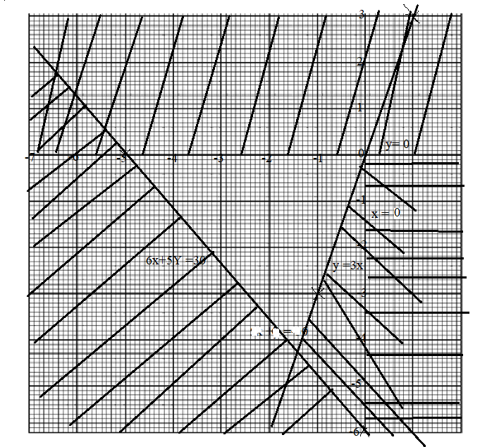
M1 M1 M1 M1 A1

- Diameter = 18y+8y = 26y cm. M1
Radius = $\frac{1}{2}$ (26y) = 13y cm.
Using $∆$ OAB, ${\left(13y\right)}^{2}={\left(5y\right)}^{2}+{\left(AB\right)}^{2}$ (pythog theo) M1
${169y}^{2}={25y}^{2}+{\left(AB\right)}^{2}$
$\left({AB}^{2}\right)={144y}^{2}$ M1
AB = 12y M1
AC = 12y $×$ 2 = 24y cm. A1

- $\frac{1}{2}\left(40+20\right)V=600$ M1
$30V=600$ M1
$V=$ 20 cm/s M1
Deceleration = $\frac{0-20}{10}$ M1
= -2 cm/s² A1

$y$
70⁰
20 m

65 m
tan70⁰ = $\frac{y}{65}$ M1
y = 65tan70⁰
y = 178. 586 m M1
The height of the tower = 178. 586 +20 M1
= 198.586
= 199 m M1 A1

- $m$ $=$ $\frac{y_{2}-y_{1}}{x_{2}-x_{1}}$
= $\frac{-1-5}{8--4}$
= $-\frac{1}{2}$ M1
$∴$ In the form of $y=mx+c,$
$y=-\frac{1}{2}x+c$
$5=-\frac{1}{2}\left(-4\right)+c$
$c=3$ M1
Equation: $y=-\frac{1}{2}x+3$
D (3, 0) and C (6, 0) M1
DC = $\sqrt{3^{2}+6^{2}}$ M1
= $\sqrt{27}$
= 3$\sqrt{3}$ A1

